Scaling

Scaling is used to change the size of an object. The size can be increased or decreased. The scaling three factors are required Sx Sy and Sz.

Sx=Scaling factor in x- direction  
Sy=Scaling factor in y-direction  
Sz=Scaling factor in z-direction

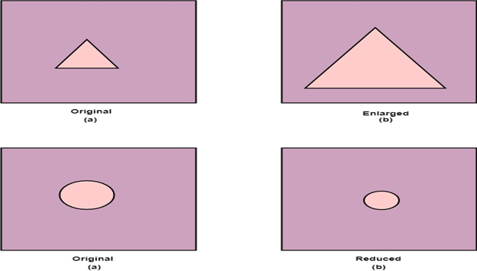

Matrix for Scaling

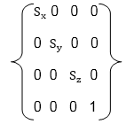

Scaling of the object relative to a fixed point

Following are steps performed when scaling of objects with fixed point (a, b, c). It can be represented as below:

1. Translate fixed point to the origin
2. Scale the object relative to the origin
3. Translate object back to its original position.

Note: If all scaling factors Sx=Sy=Sz.Then scaling is called as uniform. If scaling is done with different scaling vectors, it is called a differential scaling.

In figure (a) point (a, b, c) is shown, and object whose scaling is to done also shown in steps in fig (b), fig (c) and fig (d).

